DailyLife Android应用

开发工具：Android studio  
开发语言：Java

开发框架：MVC

后端数据提供：Bmob云数据库

Bmob云数据库：

Bmob 提供了实时数据与文件存储功能，轻松实现应用“云与端”的数据连通。数据存储除了常规应用文本信息的存储，还可以存储图片、视频、音频、地理位置等信息。

使用 Bmob 几乎能免去所有服务器端编码工作量。

集成教程文档：<http://doc.bmobapp.com/data/android/index.html>

BaseActivity/BaseFragment：每一个Activity和Fragment都是很多模板代码的，为了减少模板代码，封装进Base类其实是一种比较方便且可行的选择.

当创建新的Activity或者Fragment的时候需要想想有没有逻辑可以复用，就去找Base类，或许写Base类的人不同，发现一个项目中可能会存在多个Base类，甚至Base类仍然有多个Base子类实现不同逻辑。这个时候就需要去查看分析每个Base类分别实现了什么功能，决定继承哪个。

如果一个项目中只有一个Base类的话，仍需要看看Base类实现了什么逻辑，没有实现什么逻辑，防止重复写样板代码。

当出现Base类实现了的，而自己本身并不想需要，例如不想监听广播或者不想用ViewModel，对于不想监听广播的情况就要特殊做适配，例如往Base类加标志位。对于不想用ViewModel但是由于泛型限制，还是只能传进去，不然没法继承。

当发现自己集成Base类出BUG了，就要考虑改子类还是改Base类，由于大量的类都集成了Base类，显然改Base类比较麻烦，于是改自己比较方便。

如果一个Activity中展示了多个Fragment，可能会有业务逻辑的重复，其实只需要一个就好了。

**OKHttp框架：**

HTTP是现代应用网络请求的方式，是一个简单的请求-响应协议。在数据和媒体中进行交换。有效地请求使您的东西加载更快，并节省带宽。OKHttp是安卓开发中十分常用的网络请求框架。

**为什么使用OKHttp**

      1：缓存响应数据来减少重复的网络请求

       2：可以从很多常用的连接问题中自动恢复；（Okhttp处理了很多的网络疑难杂症：会从很多常用的连接问题中自动恢复。如果您的服        务器配置了多个IP地址，当第一个IP连接失败时，OkHttp会尝试连接下一个IP。）

       3：支持gzip压缩响应体

       4：使用简单，可扩展性非常的强；（责任链模式使得很容易添加一个自定义拦截器对请求和返回结果进行处理）

**三：用来干什么**

      1：支持一般的get请求，post请求

       2：基于Http的文件上传，文件下载，上传下载的进度回调

       3：图片加载

       4：支持请求回调，对象返回

       5:   表单请求

欢迎页面——SplashActivity

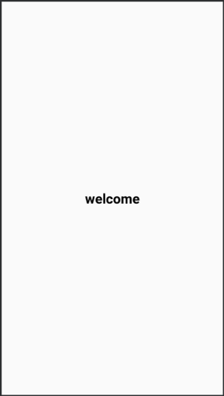

作为App的启动页面，并设置Activity为全屏

setContentView(R.layout.xxx)之前调用：

requestWindowFeature(Window.FEATURE_NO_TITLE);  
getWindow().setFlags(WindowManager.LayoutParams.FLAG_FULLSCREEN, WindowManager.LayoutParams.FLAG_FULLSCREEN);  
if (Build.VERSION.SDK_INT >= Build.VERSION_CODES.KITKAT) {  
 getWindow().addFlags(WindowManager.LayoutParams.FLAG_TRANSLUCENT_STATUS);  
 getWindow().addFlags(WindowManager.LayoutParams.FLAG_TRANSLUCENT_NAVIGATION);  
}

并使用handler进行延时1秒跳转至登录页面LoginActivity

new Handler().postDelayed(new Runnable() {  
 @Override  
 public void run() {  
 startActivity(new Intent(SplashActivity.this,LoginActivity.class));  
 }  
},1000);

**LoginActiv登录界面：**

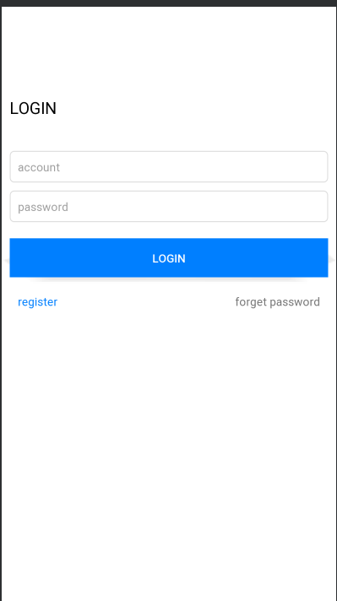

用户可通过输入手机号和密码登录，手机号采用11位校验，并提供注册和忘记密码重设功能。

监听用户点击登录按钮事件：

String phone = accountEdit.getText().toString();//获取用户输入的号  
String pwd = pwdEdit.getText().toString();//获取用户输入的密码  
  
if (TextUtils.isEmpty(phone)) {//判断输入的手机号是否为空  
 showToast("Please input phone");//提示用户手机号不能为空  
 return;  
}  
  
if (TextUtils.isEmpty(pwd)) {//判断输入的密码是否为空  
 showToast("Please input password");  
 return;  
}

//查询方法，先查询该手机号是否注册  
BmobQuery<User> query = new BmobQuery<>();  
query.addWhereEqualTo("phone", phone);//设置用户输入的手机  
query.findObjects(new FindListener<User>() {  
 @Override  
 public void done(List<User> list, BmobException e) {

//查询方法回调事件  
 if (e == null) {  
 if (list == null || list.size() == 0){//账号不存在即手机号未注册  
 Toast.makeText(mActivity, "The account does not exist", Toast.LENGTH_SHORT).show();  
 }else {  
 User user = list.get(0);//账号存在 则判断密码是否输入正确  
 if (user != null){  
 if (pwd.equals(user.getPwd())){  
 Toast.makeText(mActivity, "Login success", Toast.LENGTH_SHORT).show();  
 MyApplication.getInstance().setLoginUser(user);  
 SharedPreferenceUtil.putString(mContext,Constants.PHONE,phone);  
 startActivity(new Intent(mActivity,MainActivity.class));//登录成功跳转至主页  
 finish();  
 }else {

//提示密码输入错误  
 Toast.makeText(mActivity, "Password entered incorrectly", Toast.LENGTH_SHORT).show();  
 }  
 }  
 }  
 } else {  
 Toast.makeText(mActivity, mActivity.getResources().getString(R.string.unknown_error), Toast.LENGTH_SHORT).show();  
 }  
 }  
});

**RegisterActivity注册页面:**

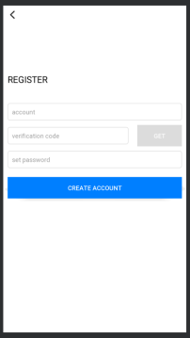

注册页面和重设密码页面公用一个页面，通过变量type判断，type等于0是注册页面，type等于1为重设密码。

通过用户输入的手机号获取短信验证码校验。

点击获取验证码按钮：

BmobSMS.requestSMSCode(phone, "DailyLife", new QueryListener<Integer>() {  
 @Override  
 public void done(Integer smsId, BmobException e) {  
 if (e == null) {

//获取成功，并开启倒计时功能  
 countDownTimer.start();  
 getCodeBtn.setBackgroundColor(mActivity.getResources().getColor(R.color.dcdcdc));  
 getCodeBtn.setEnabled(false);//倒计时中 获取验证码按钮不可用  
 if (Build.VERSION.SDK_INT >= Build.VERSION_CODES.JELLY_BEAN) {  
 getCodeBtn.setBackground(null);  
 }  
 Toast.makeText(mActivity, "The verification code is successfully obtained", Toast.LENGTH_SHORT).show();  
 Log.e(TAG, "done: " + "ID：" + smsId + "\n");  
 } else {  
 Toast.makeText(mActivity, "Failed to obtain the verification code.", Toast.LENGTH_SHORT).show();  
 Log.e(TAG, "done: " + "Failed：" + e.getErrorCode() + "-" + e.getMessage() + "\n");  
 }  
 }  
});

监听事件：

if (TextUtils.isEmpty(phone)) {  
 showToast("Please input phone");  
 return;  
}  
if (TextUtils.isEmpty(code)) {  
 showToast("Please input code");  
 return;  
}  
if (TextUtils.isEmpty(password)) {  
 showToast("Please input password");  
 return;  
}

//先查询该手机号是否已经注册  
BmobQuery<User> query = new BmobQuery<>();  
query.addWhereEqualTo("phone", phone);  
query.findObjects(new FindListener<User>() {  
 @Override  
 public void done(List<User> list, BmobException e) {  
 if (e == null) {  
 if (type == 1) {//如果为重设密码状态  
 if (list == null || list.size() == 0) { //重设密码时 账号不存在  
 Toast.makeText(mActivity, "The account does not exist", Toast.LENGTH_SHORT).show();  
 } else {  
 User user = list.get(0);//重设密码 账号存在  
 if (user != null) {  
 user.setPwd(password);//重新设置密码

//调用更新方法 进行更新密码操作  
 user.update(new UpdateListener() {  
 @Override  
 public void done(BmobException e) {  
 if (e == null) {  
 Toast.makeText(mActivity, "Succeeded in resetting the password.", Toast.LENGTH_SHORT).show();  
 SharedPreferenceUtil.putString(mActivity, Constants.PHONE, phone);  
 finish();  
 } else {  
 Toast.makeText(mActivity, mActivity.getResources().getString(R.string.unknown_error), Toast.LENGTH_SHORT).show();  
 }  
 }  
 });  
 }  
 }  
 } else {  
 if (list == null || list.size() == 0) {  
 CheckVerificationCode(phone, password, code);  
 } else {  
 Toast.makeText(mActivity, "The phone number has been registered", Toast.LENGTH_SHORT).show();  
 }  
 }  
 } else {  
 Toast.makeText(mActivity, mActivity.getResources().getString(R.string.unknown_error), Toast.LENGTH_SHORT).show();  
 }  
 }  
});

**验证短信验证码是否正确**

private void CheckVerificationCode(String phone, String password, String code,User user) {

//  
 BmobSMS.verifySmsCode(phone, code, new UpdateListener() {  
 @Override  
 public void done(BmobException e) {  
 if (e == null) {  
 if (type == 1){   
 if (user != null) {  
 user.setPwd(password);//重新设置密码  
 //调用更新方法  
 user.update(new UpdateListener() {  
 @Override  
 public void done(BmobException e) {  
 if (e == null) {  
 Toast.makeText(mActivity, "Succeeded in resetting the password.", Toast.LENGTH_SHORT).show();  
 SharedPreferenceUtil.putString(mActivity, Constants.PHONE, phone);  
 finish();  
 } else {  
 Toast.makeText(mActivity, mActivity.getResources().getString(R.string.unknown_error), Toast.LENGTH_SHORT).show();  
 }  
 }  
 });  
 }  
 }else {

//创建新用户  
 User user = new User();  
 user.setPhone(phone);  
 user.setPwd(password);

//调用保存方法  
 user.save(new SaveListener<String>() {  
 @Override  
 public void done(String s, BmobException e) {  
 if (e == null) {  
 Toast.makeText(mActivity, "Successful registration", Toast.LENGTH_SHORT).show();  
 SharedPreferenceUtil.putString(mActivity, Constants.PHONE, phone);  
 finish();  
 } else {  
 Toast.makeText(mActivity, "Registration failure", Toast.LENGTH_SHORT).show();  
 }  
 }  
 });  
 }  
  
   
 } else {  
 Toast.makeText(mActivity, "Verification code error", Toast.LENGTH_SHORT).show();  
 //mTvInfo.append("Verification code error" + e.getErrorCode() + "-" + e.getMessage() + "\n");  
 }  
 }  
 });  
}

**MainActivity 主页面：**

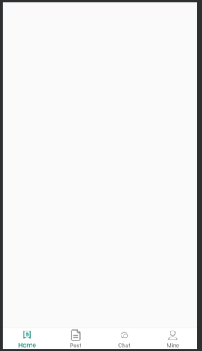  
主页面采用viewpager+bottomnavigation实现底部导航栏和左右页面联动。

MainActivity.java代码：

public class MainActivity extends BaseActivity {  
  
 @BindView(R.id.view_pager)  
 ViewPager viewPager;  
 @BindView(R.id.bottom_navigation)  
 BottomNavigationView bottomNavigation;  
  
 private HomeFragment homeFragment;  
 private PostFragment postFragment;  
 private ChatFragment chatFragment;  
 private MineFragment mineFragment;  
  
 private List<Fragment> mFragments;  
  
 @Override  
 protected void onCreate(Bundle savedInstanceState) {  
 super.onCreate(savedInstanceState);  
 //setContentView(R.layout.activity_main);  
 }  
  
 @Override  
 protected int setLayout() {  
 return R.layout.activity_main;  
 }  
  
 @Override  
 protected void initView() {  
 if (isDark) {  
 ImmersionBar.with(mActivity).statusBarColor(R.color.white).statusBarDarkFont(false).init();  
 } else {  
 ImmersionBar.with(mActivity).statusBarColor(R.color.white).statusBarDarkFont(true).init();  
 }

//实例化四个fragment  
 homeFragment = new HomeFragment();  
 postFragment = new PostFragment();  
 chatFragment = new ChatFragment();  
 mineFragment = new MineFragment();  
 mFragments = new ArrayList<>();//初始化fragment容器

//将四个fragment添加到容器中  
 mFragments.add(homeFragment);  
 mFragments.add(postFragment);  
 mFragments.add(chatFragment);  
 mFragments.add(mineFragment);  
 //viewpager绑定适配器  
 viewPager.setAdapter(new FragmentsPagerAdapter(getSupportFragmentManager()));  
 // navigationView点击事件  
 bottomNavigation.setOnNavigationItemSelectedListener(menuItem -> {  
 // menu文件夹中bottom_nav_menu.xml里加的android:orderInCategory属性就是下面item.getOrder()取的值  
 viewPager.setCurrentItem(menuItem.getOrder());//与viewpager绑定  
 return true;  
  
 });  
  
 /**  
 * 监听ViewPager页面变化事件  
 * */  
 viewPager.addOnPageChangeListener(new ViewPager.OnPageChangeListener() {  
 @Override  
 public void onPageScrolled(int position, float positionOffset, int positionOffsetPixels) {  
  
 }  
  
 @Override  
 public void onPageSelected(int position) {  
 bottomNavigation.getMenu().getItem(position).setChecked(true);//与底部导航绑定  
 }  
  
 @Override  
 public void onPageScrollStateChanged(int state) {  
  
 }  
 });  
 }  
  
 public class FragmentsPagerAdapter extends FragmentPagerAdapter{  
 private FragmentManager mFragmentManager;  
 public FragmentsPagerAdapter(FragmentManager fm) {  
 super(fm);  
 mFragmentManager = fm;  
 }  
 @Override  
 public Fragment getItem(int position) {  
 return mFragments.get(position);  
 }  
 @Override  
 public int getCount() {  
 return mFragments.size();  
 }  
 }  
  
  
}

**homeFragment：**

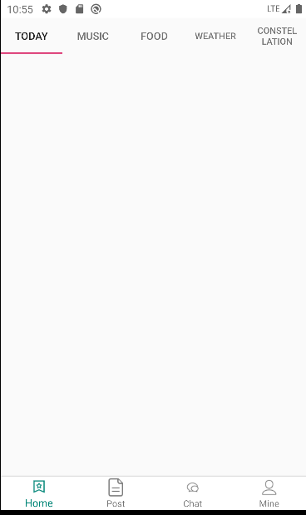

Home界面使用Tablayout+viewpager实现多页面左右滑动，TabLayout作为导航组件来说，使用场景非常的多，也意味着要满足各种各样的需求。

完整代码：

public class HomeFragment extends BaseFragment {  
 @BindView(R.id.tab_layout)  
 TabLayout tabLayout;  
 @BindView(R.id.view_pager)  
 ViewPager viewPager;  
  
 private List<Fragment> mFragments;//fragment容器  
 private ArrayList<String> mTitle;//Tablayout标题容器  
  
   
  
 @Override  
 protected int getLayoutId() {  
 return R.layout.fragment_home;  
 }  
  
 @Override  
 protected void initEventAndData() {  
 mFragments = new ArrayList<>();//初始化fragment容器

//将子fragment添加至容器  
 mFragments.add(TodayFragment.newInstance());  
 mFragments.add(MusicFragment.newInstance());  
 mFragments.add(FoodFragment.newInstance());  
 mFragments.add(WeatherFragment.newInstance());  
 mFragments.add(ConstellationFragment.newInstance());  
  
 mTitle = new ArrayList<>();

//将标题添加至容器  
 mTitle.add("Today");  
 mTitle.add("Music");  
 mTitle.add("Food");  
 mTitle.add("Weather");  
 mTitle.add("Constellation");  
  
  
 /**  
 * 预加载  
 */  
 viewPager.setOffscreenPageLimit(mFragments.size());  
 /**  
 * 设置适配器  
 */  
 viewPager.setAdapter(new FragmentPagerAdapter(getChildFragmentManager()) {  
 @Override  
 public Fragment getItem(int position) {  
 return mFragments.get(position);  
 }  
 @Override  
 public int getCount() {  
 return mFragments.size();  
 }  
 @Override  
 public CharSequence getPageTitle(int position) {  
 return mTitle.get(position);  
 }  
 });  
 tabLayout.setupWithViewPager(viewPager);//将Tablayout与viewpager进行关联  
  
 }  
  
  
 public class FragmentsPagerAdapter extends FragmentPagerAdapter {  
 private FragmentManager mFragmentManager;  
 public FragmentsPagerAdapter(FragmentManager fm) {  
 super(fm);  
 mFragmentManager = fm;  
 }  
 @Override  
 public Fragment getItem(int position) {  
 return mFragments.get(position);  
 }  
 @Override  
 public int getCount() {  
 return mFragments.size();  
 }  
 }  
  
}

**TodayFragment（今日咨询推荐页面）：**

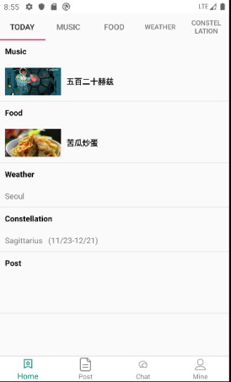

页面用于各项推荐数据，

使用OkHttp网络框架请求数据，并对返回的json数据用GSON解析。

public class TodayFragment extends BaseFragment {  
  
 @BindView(R.id.recycler_view)  
 RecyclerView recyclerView;  
  
 NewsListAdapter newsListAdapter;  
  
 public static TodayFragment newInstance() {  
 TodayFragment fragment = new TodayFragment();  
 Bundle args = new Bundle();  
  
 fragment.setArguments(args);  
 return fragment;  
 }  
  
  
 @Override  
 protected int getLayoutId() {  
 return R.layout.fragment_today;  
 }  
  
 @Override  
 protected void initEventAndData() {

//设置列表的加载方向：纵向  
 recyclerView.setLayoutManager(new LinearLayoutManager(mContext));  
 newsListAdapter = new NewsListAdapter();  
 newsListAdapter.bindToRecyclerView(recyclerView);  
 newsListAdapter.setOnItemClickListener((adapter, view, position) -> {  
 NewsData bean = newsListAdapter.getItem(position);  
 if (bean == null)return;  
 Intent intent = new Intent(mContext, NewsDetailsActivity.class);  
 intent.putExtra(Constants.ID,bean.getDocid());  
 intent.putExtra(Constants.TITLE,bean.getTitle());  
 startActivity(intent);  
  
 });  
 getNewsDatat();  
  
 }  
  
 private void getNewsDatat() {  
 //1.拿到okHttpClient对象,可以设置连接超时等  
 OkHttpClient okHttpClient = new OkHttpClient();  
  
 //2.构造Request请求对象，可以增加头addHeader等  
 Request.Builder builder = new Request.Builder();  
 //url()中可以放入网址  
 Request request = builder.  
 get().  
 url("https://v2.alapi.cn/api/new/toutiao?start=1&token="+ MyApplication.getInstance().getToken())  
 .build();  
 //3.将Request封装为Call  
 Call call = okHttpClient.newCall(request);  
 //4.执行call  
 //方法一Response response=call.execute();//汇抛出IO异常，同步方法  
 //方法二,异步方法，放到队列中,处于子线程中，无法更新UI  
 call.enqueue(new Callback() {  
 //请求时失败时调用  
 @Override  
 public void onFailure(Call call, IOException e) {  
  
 }  
  
 //请求成功时调用  
 @Override  
 public void onResponse(Call call, Response response) throws IOException {  
 //处于子线程中，能够进行大文件下载，但是无法更新UI  
 final String res = response.body().string();//请求成功时返回的东西  
 Log.e(TAG, "onResponse: " + res);  
  
 //InputStream is=response.body().byteStream();  
 // 执行IO操作时，能够下载很大的文件，并且不会占用很大内存  
 /**  
 * runOnUiThread方法切换到主线程中，或者用handler机制也可以  
 */  
  
 NewsRoot newsRoot = new Gson().fromJson(res, NewsRoot.class);  
 mActivity.runOnUiThread(new Runnable() {  
 @Override  
 public void run() {  
 // 更新ui  
 if (newsRoot != null && newsRoot.getData() != null && newsListAdapter != null) {  
 newsListAdapter.setNewData(newsRoot.getData());  
 }  
 }  
 });  
  
 }  
 });  
 }  
  
}

**NewsDetailsActivity（详情页面）**

public class NewsDetailsActivity extends BaseActivity {  
  
 @BindView(R.id.back_img)  
 ImageView backImg;  
 @BindView(R.id.title_tv)  
 TextView titleTv;  
 @BindView(R.id.right_tv)  
 TextView rightTv;  
 @BindView(R.id.content_tv)  
 TextView contentTv;  
 @BindView(R.id.news_title_tv)  
 TextView newsTitleTv;  
 @BindView(R.id.info_tv)  
 TextView infoTv;  
  
 private String docId;//新闻ID  
  
 @Override  
 protected void onCreate(Bundle savedInstanceState) {  
 super.onCreate(savedInstanceState);  
 //setContentView(R.layout.activity_news_details);  
 }  
  
 @Override  
 protected void initView() {  
 if (isDark) {  
 ImmersionBar.with(mActivity).statusBarColor(R.color.white).statusBarDarkFont(false).init();  
 } else {  
 ImmersionBar.with(mActivity).statusBarColor(R.color.white).statusBarDarkFont(true).init();  
 }  
  
 docId = getIntent().getStringExtra(Constants.ID);//接收上个页面传递过来的数据  
 newsTitleTv.setText(getIntent().getStringExtra(Constants.TITLE));  
  
 //1.拿到okHttpClient对象,可以设置连接超时等  
 OkHttpClient okHttpClient = new OkHttpClient();  
  
 //2.构造Request请求对象，可以增加头addHeader等  
 Request.Builder builder = new Request.Builder();  
 //url()中可以放入网址  
 Request request = builder.  
 get().  
 url("https://v2.alapi.cn/api/new/detail?docid=" + docId + "&token="+ MyApplication.getInstance().getToken())  
 .build();  
 //3.将Request封装为Call  
 Call call = okHttpClient.newCall(request);  
 //4.执行call  
 //方法一Response response=call.execute();//汇抛出IO异常，同步方法  
 //方法二,异步方法，放到队列中,处于子线程中，无法更新UI  
 call.enqueue(new Callback() {  
 //请求时失败时调用  
 @Override  
 public void onFailure(Call call, IOException e) {  
  
 }  
  
 //请求成功时调用  
 @Override  
 public void onResponse(Call call, Response response) throws IOException {  
 //处于子线程中，能够进行大文件下载，但是无法更新UI  
 final String res = response.body().string();//请求成功时返回的东西  
 //InputStream is=response.body().byteStream();  
 // 执行IO操作时，能够下载很大的文件，并且不会占用很大内存  
 /**  
 * runOnUiThread方法切换到主线程中，或者用handler机制也可以  
 */  
 Log.e(TAG, "onResponse: "+res);  
 NewDetailsRoot newDetailsRoot = new Gson().fromJson(res, NewDetailsRoot.class);  
 if (newDetailsRoot != null && newDetailsRoot.getData() != null) {  
 String str = newDetailsRoot.getData().getBody();  
 String info = "来自："+newDetailsRoot.getData().getSource()+" "+newDetailsRoot.getData().getPtime()+"\n"+newDetailsRoot.getData().getCategory();  
 if (newDetailsRoot.getData().getImg() != null && newDetailsRoot.getData().getImg().size() > 0) {  
 for (NewDetailsData.Img img : newDetailsRoot.getData().getImg()) {  
 if (str.contains(img.getRef())) {  
 String[] ss = img.getPixel().split("\\*");  
 str = str.replaceAll(img.getRef(), "<img height=\\\"" + ss[0] + "px\\\" width=\\\"100%\\\" src=\\\"" + img.getSrc() + "\\\"/>");  
 }  
 }  
 Log.e(TAG, "run: " + str);  
 }  
 final Spanned sp = Html.fromHtml(str, source -> {  
 InputStream is;  
 try {  
 is = (InputStream) new URL(source).getContent();  
 Drawable d = Drawable.createFromStream(is, "src");  
 d.setBounds(0, 0, d.getIntrinsicWidth(),  
 d.getIntrinsicHeight());  
 is.close();  
 return d;  
 } catch (Exception e) {  
 return null;  
 }  
 }, null);  
 mActivity.runOnUiThread(() -> {  
 // 更新ui  
 contentTv.setText(sp);  
 infoTv.setText(info);  
  
 });  
 }  
 }  
 });  
  
  
 }  
  
 @Override  
 protected int setLayout() {  
 return R.layout.activity_news_details;  
 }  
  
 @OnClick({R.id.back_img, R.id.title_tv})  
 public void onViewClicked(View view) {  
 switch (view.getId()) {  
 case R.id.back_img:  
 finish(); //返回键 直接退出页面  
 break;  
 case R.id.title_tv:  
 break;  
 }  
 }  
  
 @Override  
 public void onBackPressed() {  
 super.onBackPressed();  
 finish();  
 }  
}

**MusicFragment（音乐页面）：**

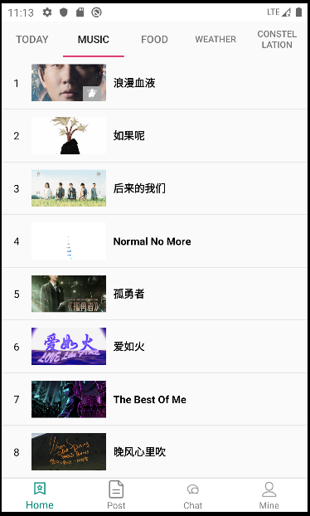

使用公用免费API查询 网易云音乐热歌榜，url地址："https://api.uomg.com/api/rand.music?sort=热歌榜&format=json"

public class MusicFragment extends BaseFragment {  
  
 @BindView(R.id.recycler_view)  
 RecyclerView recyclerView;  
  
 private MusicListAdapter musicListAdapter;  
 private int pageSize = 1;  
 private Set<String> stringSet = new HashSet<>();  
  
 public static MusicFragment newInstance() {  
 MusicFragment fragment = new MusicFragment();  
 Bundle args = new Bundle();  
  
 fragment.setArguments(args);  
 return fragment;  
 }  
  
  
 @Override  
 protected int getLayoutId() {  
 return R.layout.fragment_music;  
 }  
  
 @Override  
 protected void initEventAndData() {  
  
  
 recyclerView.setLayoutManager(new LinearLayoutManager(mContext));  
 musicListAdapter = new MusicListAdapter();  
 musicListAdapter.bindToRecyclerView(recyclerView);  
 musicListAdapter.setOnItemClickListener((adapter, view, position) -> {  
 MusicData bean = musicListAdapter.getItem(position);  
 if (bean == null)return;  
 Uri uri = Uri.parse(bean.getUrl());  
 Intent intent = new Intent(Intent.ACTION_VIEW, uri);  
 startActivity(intent);  
 });  
  
 getMusicData();  
  
  
 }  
  
 private void getMusicData() {  
 //1.拿到okHttpClient对象,可以设置连接超时等  
 OkHttpClient okHttpClient = new OkHttpClient();  
 //2.构造Request请求对象，可以增加头addHeader等  
 Request.Builder builder = new Request.Builder();  
 //url()中可以放入网址  
 //使用公用免费API查询 网易云音乐热歌榜  
 Request request = builder.  
 get().  
 url("https://api.uomg.com/api/rand.music?sort=热歌榜&format=json")  
 .build();  
 //3.将Request封装为Call  
 Call call = okHttpClient.newCall(request);  
 //4.执行call  
 //方法一Response response=call.execute();//汇抛出IO异常，同步方法  
 //方法二,异步方法，放到队列中,处于子线程中，无法更新UI  
 call.enqueue(new Callback() {  
 //请求时失败时调用  
 @Override  
 public void onFailure(Call call, IOException e) {  
  
 }  
  
 //请求成功时调用  
 @Override  
 public void onResponse(Call call, Response response) throws IOException {  
 //处于子线程中，能够进行大文件下载，但是无法更新UI  
 final String res = response.body().string();//请求成功时返回的东西  
 //InputStream is=response.body().byteStream();  
 // 执行IO操作时，能够下载很大的文件，并且不会占用很大内存  
 /**  
 * runOnUiThread方法切换到主线程中，或者用handler机制也可以  
 */  
 Log.e(TAG, "onResponse: "+res);  
 MusicRoot musicRoot = new Gson().fromJson(res, MusicRoot.class);  
  
 if (musicRoot != null && musicRoot.getData() != null) {  
 mActivity.runOnUiThread(() -> {  
 if (stringSet.add(musicRoot.getData().getName())){  
 musicListAdapter.addData(musicRoot.getData());  
 pageSize++;  
 }  
 if (pageSize <= 20){ //只查询前20首  
 getMusicData();  
 }  
 });  
 }  
 }  
 });  
 }  
  
  
}

**FoodFragment（美食页面）**

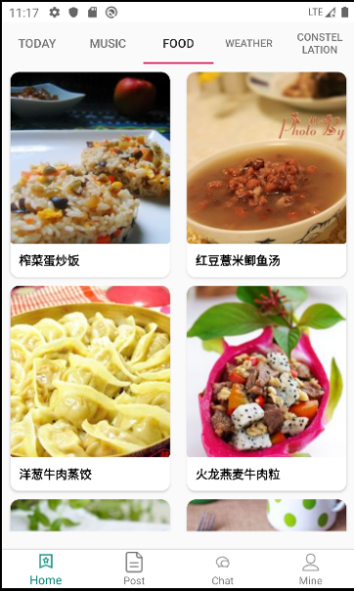

美食页面采用recyclerview展示数据，并使用GridlayouMananger实现网格列表布局。

public class FoodFragment extends BaseFragment {  
  
 @BindView(R.id.recycler_view)  
 RecyclerView recyclerView;  
 private String[] keywords = {"蛋","鱼","豆腐","牛肉"};  
 private int num = 10;  
 private FoodListAdapter foodListAdapter;  
  
 public static FoodFragment newInstance() {  
 FoodFragment fragment = new FoodFragment();  
 Bundle args = new Bundle();  
  
 fragment.setArguments(args);  
 return fragment;  
 }  
  
  
 @Override  
 protected int getLayoutId() {  
 return R.layout.fragment_food;  
 }  
  
 @Override  
 protected void initEventAndData() {  
 //使用网格布局，一行2列  
 recyclerView.setLayoutManager(new GridLayoutManager(mContext, 2));  
 foodListAdapter = new FoodListAdapter();  
 foodListAdapter.bindToRecyclerView(recyclerView);  
 foodListAdapter.setOnItemClickListener((adapter, view, position) -> {  
 Food food = foodListAdapter.getItem(position);  
 if (food == null)return;  
 Intent intent = new Intent(mContext, FoodDetilsActivity.class);  
 intent.putExtra(Constants.DATA,food);  
 startActivity(intent);  
  
 });  
 getBmobData();  
  
  
 //getData();  
  
 }  
  
 private void getBmobData() {  
  
 BmobQuery<Food> query = new BmobQuery<>();  
 query.order("-createdAt")//查找所有数据，并根据事件降序排列  
 .findObjects(new FindListener<Food>() {  
 @Override  
 public void done(List<Food> object, BmobException e) {  
 if (e == null) {  
 if (object != null){  
 Collections.shuffle(object);//随机打乱顺序  
 foodListAdapter.setNewData(object);  
 }  
 } else {  
  
 }  
 }  
 });  
 }  
  
 private void getData() {  
 //1.拿到okHttpClient对象,可以设置连接超时等  
 OkHttpClient okHttpClient = new OkHttpClient();  
 //2.构造Request请求对象，可以增加头addHeader等  
 Request.Builder builder = new Request.Builder();  
 String url = "https://way.jd.com/jisuapi/search?keyword="+keywords[3]  
 /*+ keywords[new Random().nextInt(keywords.length)]*/ +  
 "&num=" + num + "&appkey=" + MyApplication.getInstance().getApiKey();  
 Log.e(TAG, "url: "+url);  
 //url()中可以放入网址  
 Request request = builder.  
 get().url(url)  
 .build();  
 //3.将Request封装为Call  
 Call call = okHttpClient.newCall(request);  
 //4.执行call  
 //方法一Response response=call.execute();//汇抛出IO异常，同步方法  
 //方法二,异步方法，放到队列中,处于子线程中，无法更新UI  
 call.enqueue(new Callback() {  
 //请求时失败时调用  
 @Override  
 public void onFailure(Call call, IOException e) {  
  
 }  
  
 //请求成功时调用  
 @Override  
 public void onResponse(Call call, Response response) throws IOException {  
 //处于子线程中，能够进行大文件下载，但是无法更新UI  
 final String res = response.body().string();//请求成功时返回的东西  
 //InputStream is=response.body().byteStream();  
 // 执行IO操作时，能够下载很大的文件，并且不会占用很大内存  
 /**  
 * runOnUiThread方法切换到主线程中，或者用handler机制也可以  
 */  
 Log.e(TAG, "onResponse: " + res);  
 setData(res);  
 }  
 });  
 }  
  
 private void setData(String res) {  
 FoodRoot foodRoot = new Gson().fromJson(res, FoodRoot.class);  
 if (foodRoot != null && foodRoot.getResult() != null && foodRoot.getResult().getResult() != null  
 && foodRoot.getResult().getResult().getList() != null) {  
 mActivity.runOnUiThread(() -> {  
  
 foodListAdapter.addData(foodRoot.getResult().getResult().getList());  
 });  
 }  
 }  
  
  
}

WeatherFragment：（天气页面）

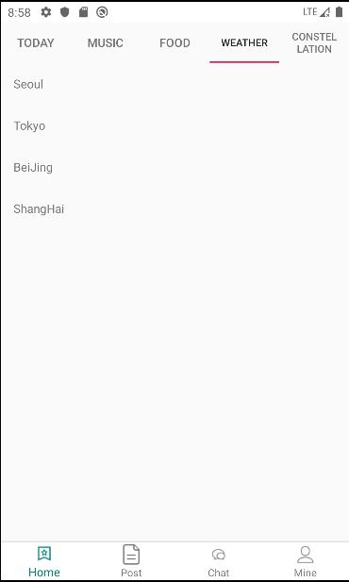

用列表展示城市列表数据，点击某个城市跳转进入具体城市的天气详情页面：

WeatherActivity：使用Handler机制更新UI

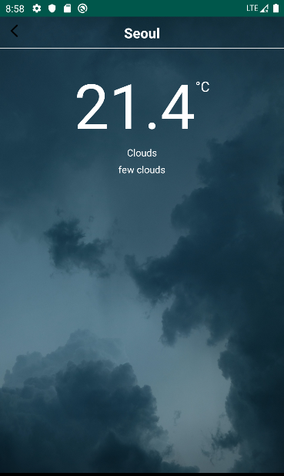

public class WeaterActivity extends BaseActivity {  
  
  
 @BindView(R.id.back_img)  
 ImageView backImg;  
 @BindView(R.id.title_tv)  
 TextView titleTv;  
 @BindView(R.id.right_tv)  
 TextView rightTv;  
 @BindView(R.id.city_tv)  
 TextView cityTv;  
 @BindView(R.id.center_tv)  
 TextView centerTv;  
 @BindView(R.id.wind_tv)  
 TextView windTv;  
 @BindView(R.id.humidity_tv)  
 TextView humidityTv;  
 @BindView(R.id.list_view)  
 ListView listView;  
 @BindView(R.id.fragment_layout)  
 FrameLayout frameLayout;  
  
  
 //通过Handler 机制循环取出数据  
 @SuppressLint("HandlerLeak")  
 private Handler handler = new Handler() {  
  
 @Override  
 public void handleMessage(@NonNull Message msg) {  
 super.handleMessage(msg);  
 if (msg.what == 0) {  
 if (jsonRootBean != null) {  
 if (jsonRootBean.getResult() != null) {  
 if (jsonRootBean.getResult().getRealtime() != null) {  
 centerTv.setText(jsonRootBean.getResult().getRealtime().getTemperature());  
 windTv.setText(jsonRootBean.getResult().getRealtime().getDirect() + " " +  
 jsonRootBean.getResult().getRealtime().getPower());  
 humidityTv.setText("湿度 " + jsonRootBean.getResult().getRealtime().getWid());  
 if ("晴".equals(jsonRootBean.getResult().getRealtime().getInfo())) {  
 frameLayout.setBackgroundResource(R.drawable.ic_sunny);  
 }  
 if ("阴".equals(jsonRootBean.getResult().getRealtime().getInfo())) {  
 frameLayout.setBackgroundResource(R.drawable.ic_cloudy_day);  
 }  
 if (!TextUtils.isEmpty(jsonRootBean.getResult().getRealtime().getInfo()) &&  
 jsonRootBean.getResult().getRealtime().getInfo().contains("雨")) {  
 frameLayout.setBackgroundResource(R.drawable.ic_rain);  
 }  
 }  
 if (jsonRootBean.getResult().getFuture() != null) {  
 //将数据和context通过自定义Adapter的构造方法传给Adapter  
 MyAdapter adapter = new MyAdapter(jsonRootBean.getResult().getFuture(), mActivity);  
 listView.setAdapter(adapter);  
 }  
  
 }  
  
 }  
 }  
 }  
  
  
 };  
 private String city;  
 private String key = "639e250e02d5dd2b4f6647f817a3680b";  
 private JsonRootBean jsonRootBean;  
  
  
 @Override  
 protected void initView() {  
 city = getIntent().getStringExtra(Constants.DATA);  
 cityTv.setText(city);  
 getData(city);  
 }  
  
  
 private void getData(String city) {  
  
 //1.拿到okHttpClient对象,可以设置连接超时等  
 OkHttpClient okHttpClient = new OkHttpClient();  
 //2.构造Request请求对象，可以增加头addHeader等  
 Request.Builder builder = new Request.Builder();  
 String url = "http://apis.juhe.cn/simpleWeather/query?city=" + city + "&key=" + key;  
 Log.e(TAG, "url: " + url);  
 //url()中可以放入网址  
 Request request = builder.  
 get().url(url)  
 .build();  
 //3.将Request封装为Call  
 Call call = okHttpClient.newCall(request);  
 //4.执行call  
 //方法一Response response=call.execute();//汇抛出IO异常，同步方法  
 //方法二,异步方法，放到队列中,处于子线程中，无法更新UI  
 call.enqueue(new Callback() {  
 //请求时失败时调用  
 @Override  
 public void onFailure(Call call, IOException e) {  
 Log.e("onFailure", e.getMessage());  
  
 }  
  
 //请求成功时调用  
 @Override  
 public void onResponse(Call call, Response response) throws IOException {  
 //处于子线程中，能够进行大文件下载，但是无法更新UI  
 /**  
 * runOnUiThread方法切换到主线程中，或者用handler机制也可以  
 */  
 final String result = response.body().string();//请求成功时返回的东西  
 Log.e("onResponse", result);  
 if (!TextUtils.isEmpty(result)) {  
 jsonRootBean = new Gson().fromJson(result, JsonRootBean.class);  
 //定义消息对象  
 Message message = new Message();  
 message.what = 0;  
 handler.sendMessage(message);  
 }  
  
 }  
 });  
 }  
  
 @Override  
 protected int setLayout() {  
 return R.layout.activity_weater;  
 }  
  
  
 @Override  
 protected void onCreate(Bundle savedInstanceState) {  
 super.onCreate(savedInstanceState);  
  
 }  
  
 @OnClick({R.id.back_img, R.id.title_tv})  
 public void onViewClicked(View view) {  
 switch (view.getId()) {  
 case R.id.back_img:  
 finish();  
 break;  
 case R.id.title_tv:  
 break;  
 }  
 }  
  
 @Override  
 public void onBackPressed() {  
 super.onBackPressed();  
 finish();  
 }  
  
  
 public class MyAdapter extends BaseAdapter {  
 private List<Future> productions = null;  
 private Context context = null;  
  
 public MyAdapter(List<Future> productions, Context context) {  
 super();  
 this.productions = productions;  
 this.context = context;  
 }  
  
 @Override  
 public int getCount() {  
 return productions.size();  
 }  
  
 @Override  
 public Object getItem(int position) {  
 return productions.get(position);  
 }  
  
 @Override  
 public long getItemId(int position) {  
 return position;  
 }  
  
 @Override  
 public View getView(int position, View convertView, ViewGroup parent) {  
 //获取到ListView的子项  
 convertView = LayoutInflater.from(context).inflate(R.layout.list_view_item, null);  
  
 TextView tv_left = convertView.findViewById(R.id.left_tv);  
 TextView tv_right = convertView.findViewById(R.id.right_tv);  
 //待组装的每一个item的bean，从bean中取出数据  
 Future future = productions.get(position);  
 if (position == 0) {  
 tv_left.setText("今天·" + future.getWeather());  
 tv_right.setText(future.getTemperature());  
 } else if (position == 1) {  
 tv_left.setText("明天·" + future.getWeather());  
 tv_right.setText(future.getTemperature());  
 } else if (position == 2) {  
 tv_left.setText("后天·" + future.getWeather());  
 tv_right.setText(future.getTemperature());  
 } else {  
 tv_left.setText(future.getDate() + "·" + future.getWeather());  
 tv_right.setText(future.getTemperature());  
 }  
 /* purchase.setOnClickListener(new View.OnClickListener() {  
 @Override  
 public void onClick(View v) {  
 Toast.makeText(context, "点的是第" + (position + 1) + "行", Toast.LENGTH_LONG).show();  
 }  
 });*/  
 return convertView;  
 }  
 }  
}

**ConstellationFragment：星座页面**

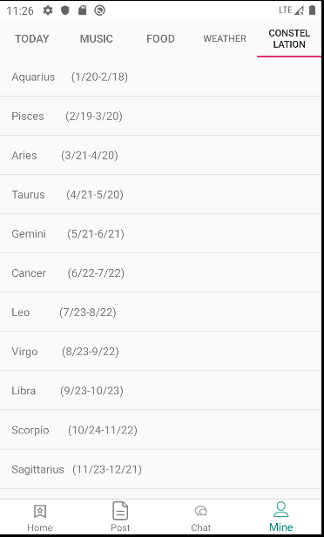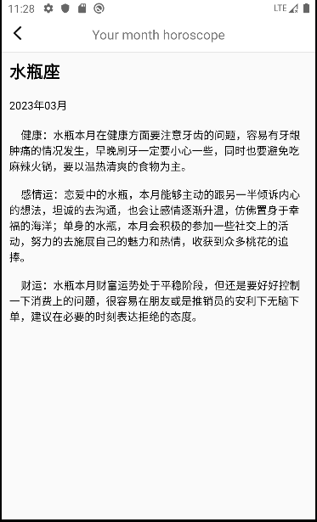

public class ConstellationFragment extends BaseFragment {  
  
 @BindView(R.id.recycler_view)  
 RecyclerView recyclerView;  
 List<String> stringList = new ArrayList<>();  
 ConstellationAdapter constellationAdapter;  
  
  
 public static ConstellationFragment newInstance() {  
 ConstellationFragment fragment = new ConstellationFragment();  
 Bundle args = new Bundle();  
  
 fragment.setArguments(args);  
 return fragment;  
 }  
  
  
 @Override  
 protected int getLayoutId() {  
 return R.layout.fragment_constellation;  
 }  
  
 @Override  
 protected void initEventAndData() {  
  
 recyclerView.setLayoutManager(new LinearLayoutManager(mContext));  
 //创建12星座数据  
 stringList.add("Aquarius (1/20-2/18)");  
 stringList.add("Pisces (2/19-3/20)");  
 stringList.add("Aries (3/21-4/20)");  
 stringList.add("Taurus (4/21-5/20)");  
 stringList.add("Gemini (5/21-6/21)");  
 stringList.add("Cancer (6/22-7/22)");  
 stringList.add("Leo (7/23-8/22)");  
 stringList.add("Virgo (8/23-9/22)");  
 stringList.add("Libra (9/23-10/23)");  
 stringList.add("Scorpio (10/24-11/22)");  
 stringList.add("Sagittarius (11/23-12/21)");  
 stringList.add("Capricorn (12/22-1/20)");  
  
 constellationAdapter = new ConstellationAdapter();  
 constellationAdapter.bindToRecyclerView(recyclerView);  
 constellationAdapter.setNewData(stringList);  
 constellationAdapter.setOnItemClickListener((adapter, view, position) -> {  
 Intent intent = new Intent(mContext, ConstellationActivity.class);  
 intent.putExtra(Constants.POSITION,position);  
 startActivity(intent);  
 });  
 }  
}

PostFragment：帖子列表界面

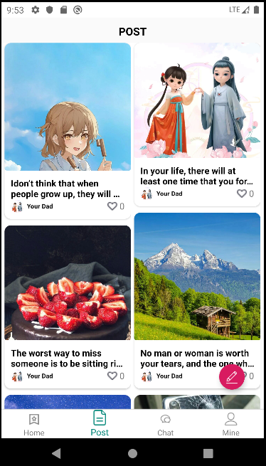

使用原生控件SwipeRefreshLayout下拉刷新，并使用recyclerView加载post数据，设置Layoutmanager为瀑布流

public class PostFragment extends BaseFragment {  
 @BindView(R.id.recycler_view)  
 RecyclerView recyclerView;  
 @BindView(R.id.floating_btn)  
 FloatingActionButton floatingBtn;  
 @BindView(R.id.refresh_layout)  
 SwipeRefreshLayout refreshLayout;  
 private PostAdapter postAdapter;  
 private StaggeredGridLayoutManager layoutManager;  
  
  
  
 /* @Override  
 public View onCreateView(LayoutInflater inflater, ViewGroup container,  
 Bundle savedInstanceState) {  
 // Inflate the layout for this fragment  
 return inflater.inflate(R.layout.fragment_post, container, false);  
 }*/  
  
 @Override  
 protected int getLayoutId() {  
 return R.layout.fragment_post;  
 }  
  
 @Override  
 protected void initEventAndData() {  
 layoutManager = new StaggeredGridLayoutManager(2, StaggeredGridLayoutManager.VERTICAL);  
 //防止item 交换位置  
 layoutManager.setGapStrategy(StaggeredGridLayoutManager.GAP_HANDLING_NONE);  
  
 recyclerView.setLayoutManager(layoutManager);  
 postAdapter = new PostAdapter();  
 postAdapter.bindToRecyclerView(recyclerView);  
 postAdapter.setOnItemClickListener((adapter, view, position) -> {  
 Post post = postAdapter.getItem(position);  
 if (post == null) return;  
 startActivity(new Intent(mContext, PostDetailActivity.class)  
 .putExtra(Constants.ID, post.getObjectId()));  
 });  
 getData();  
 refreshLayout.setOnRefreshListener(new SwipeRefreshLayout.OnRefreshListener() {  
 @Override  
 public void onRefresh() {  
 //刷新获取数据  
 getData();  
 }  
 });  
  
 //防止拖动过程中顶部出现空白  
 recyclerView.addOnScrollListener(new RecyclerView.OnScrollListener() {  
 @Override  
 public void onScrollStateChanged(RecyclerView recyclerView, int newState) {  
 super.onScrollStateChanged(recyclerView, newState);  
 //防止第一行到顶部有空白区域  
 layoutManager.invalidateSpanAssignments();  
 }  
 });  
  
 }  
  
 private void getData() {  
 BmobQuery<Post> query = new BmobQuery<>();  
 //希望同时查询该评论的发布者的信息，以及该帖子的作者的信息，这里用到上面`include`的并列对象查询和内嵌对象的查询  
 query.include("author");  
 query.order("-updatedAt");  
 query.findObjects(new FindListener<Post>() {  
 @Override  
 public void done(List<Post> list, BmobException e) {  
 if (e == null) {  
 if (list != null) {  
 if (list.size() > 0)  
 LiveEventBus.get("postData").post(list.get(new Random().nextInt(list.size())));  
 postAdapter.setNewData(list);  
 }  
 }  
 refreshLayout.setRefreshing(false);  
 }  
 });  
  
 }  
  
  
 @OnClick({R.id.floating_btn})  
 public void onViewClicked(View view) {  
 switch (view.getId()) {  
 case R.id.floating_btn:  
 //浮动按钮点击跳转至发布帖子页面  
 startActivityForResult(new Intent(mContext, RelastePostActivity.class)  
 , 110);  
 break;  
 }  
 }  
  
  
 @Override  
 public void onActivityResult(int requestCode, int resultCode, @Nullable Intent data) {  
 super.onActivityResult(requestCode, resultCode, data);  
 //新建发帖子成功后 回调事件 并将新数据加在列表第一位  
 if (requestCode == 110 && resultCode == RESULT_OK) {  
 if (data != null) {  
 String str = data.getStringExtra(Constants.ID);  
 if (TextUtils.isEmpty(str))  
 return;  
 BmobQuery<Post> categoryBmobQuery = new BmobQuery<>();  
 categoryBmobQuery.getObject(str, new QueryListener<Post>() {  
 @Override  
 public void done(Post object, BmobException e) {  
 if (e == null) {  
 if (object != null) {  
 postAdapter.addData(0, object);  
 }  
 //Snackbar.make(mBtnEqual, "查询成功：" + object.size(), Snackbar.LENGTH_LONG).show();  
 } else {  
 Log.e("BMOB", e.toString());  
 //Snackbar.make(mBtnEqual, e.getMessage(), Snackbar.LENGTH_LONG).show();  
 }  
 }  
 });  
  
 }  
 }  
 }  
}

创建帖子页面：ReleasePostActivity

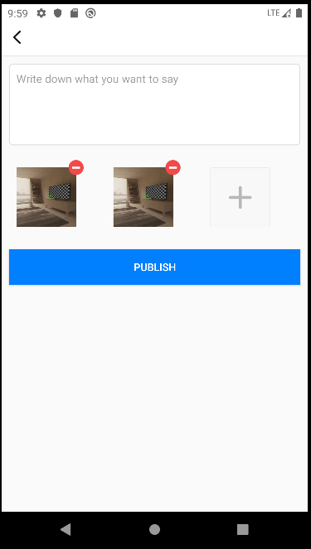

提供Editext输入框输入文字内容，并使用GirdView实现图片九宫格效果

完整代码：

public class RelastePostActivity extends BaseActivity {  
  
 @BindView(R.id.back_img)  
 ImageView backImg;  
 @BindView(R.id.title_tv)  
 TextView titleTv;  
 @BindView(R.id.right_tv)  
 TextView rightTv;  
 @BindView(R.id.content_edit)  
 EditText contentEdit;  
 @BindView(R.id.grid_view)  
 MyGridView gridView;  
 @BindView(R.id.login_btn)  
 Button loginBtn;  
  
 private GridAdapter gridAdapter;  
 private boolean isEdit = true;  
 private boolean isAdd = true;  
 private int i = 9;  
 private ArrayList<String> imageList = new ArrayList<>();  
 private int requset_photo = 11;  
 private Map<String, BmobFile> map = new HashMap<>();  
 private StringBuilder img = new StringBuilder();  
 private User loginUser;  
 private ProgressDialog progressDialog;  
 @Override  
 protected void onCreate(Bundle savedInstanceState) {  
 super.onCreate(savedInstanceState);  
 //setContentView(R.layout.activity_relaste_post);  
 }  
  
 @Override  
 protected void initView() {  
 if (isDark) {  
 ImmersionBar.with(mActivity).statusBarColor(R.color.white).statusBarDarkFont(false).init();  
 } else {  
 ImmersionBar.with(mActivity).statusBarColor(R.color.white).statusBarDarkFont(true).init();  
 }  
 loginUser = MyApplication.getInstance().getUser();  
 gridAdapter = new GridAdapter(imageList, mContext, isEdit, isAdd);  
 gridView.setAdapter(gridAdapter);  
 gridView.setOnItemClickListener((parent, view, position, id) -> {  
 requestPermissions(parent, view, position, id);  
 }  
 );  
 }  
  
  
 private void requestPermissions(AdapterView<?>  
 adapterView, View view, int i, long l) {  
 if (Build.VERSION.SDK_INT >= Build.VERSION_CODES.M) {  
 // TODO 申请权限成功。  
 if (XXPermissions.isGranted(mContext, Manifest.permission.WRITE_EXTERNAL_STORAGE,  
 Manifest.permission.CAMERA,  
 Manifest.permission.READ_EXTERNAL_STORAGE)) {  
 Log.i(TAG, "hasPermission: ");  
 if (i == adapterView.getChildCount() - 1) {  
 //如果“增加按钮形状的”图片的位置是最后一张，且添加了的图片的数量不超过 ContastUtil.MAX_IMAGES 张，才能点击  
 if (imageList.size() == 9) {  
 //viewPluImg(i, imageList);  
 } else {  
 //添加凭证图片  
 selectPic(9 - imageList.size());  
 }  
 } else {  
 //viewPluImg(i, imageList);  
 }  
 } else {  
 //请求读写权限 获取手机相册图片数据  
 XXPermissions.with(this)  
 .permission(Manifest.permission.WRITE_EXTERNAL_STORAGE,  
 Manifest.permission.CAMERA,  
 Manifest.permission.READ_EXTERNAL_STORAGE)  
 .request(new OnPermissionCallback() {  
 @Override  
 public void onGranted(List<String> permissions, boolean all) {  
 if (all) {  
  
 } else {  
  
 }  
 }  
  
 @Override  
 public void onDenied(List<String> permissions, boolean never) {  
 if (never) {  
 // 如果是被永久拒绝就跳转到应用权限系统设置页面  
 XXPermissions.startPermissionActivity(mContext, permissions);  
 }  
 showToast("Authorization failure");  
 }  
 });  
 }  
 } else {  
 Log.i(TAG, "SDK_INT: ");  
 if (i == adapterView.getChildCount() - 1) {  
 //如果“增加按钮形状的”图片的位置是最后一张，且添加了的图片的数量不超过 ContastUtil.MAX_IMAGES 张，才能点击  
 if (imageList.size() == 9) {  
 //最多添加50张图片  
 //viewPluImg(i, imageList);  
 } else {  
 //添加凭证图片  
 selectPic(9 - imageList.size());  
 }  
 } else {  
 // viewPluImg(i, imageList);  
 }  
 }  
 }  
  
 private void selectPic(int i) {  
 PictureSelector.create(this)  
 .openGallery(PictureMimeType.ofImage())  
 .maxSelectNum(9)  
 .isCamera(true)  
 .enableCrop(false)  
 .withAspectRatio(1, 1)  
 .compress(true)  
 .cropCompressQuality(40)  
 .forResult(requset_photo);  
 }  
  
 @Override  
 protected int setLayout() {  
 return R.layout.activity_relaste_post;  
 }  
  
 @OnClick({R.id.back_img, R.id.login_btn})  
 public void onViewClicked(View view) {  
 switch (view.getId()) {  
 case R.id.back_img:  
 finish();  
 break;  
 case R.id.login_btn:  
 String context = contentEdit.getText().toString();  
 if (TextUtils.isEmpty(context)) {  
 showToast(contentEdit.getHint().toString());  
 return;  
 }  
 if (imageList == null || imageList.size() == 0) {  
 showToast("Please add pictures");  
 return;  
 }  
  
 loginBtn.setEnabled(false);  
  
 Log.e(TAG, "onViewClicked: " + img.toString());  
 Post post = new Post();  
 post.setContent(context);  
 post.setAuthor(loginUser);  
 post.setImage(img.toString());  
 post.save(new SaveListener<String>() {  
 @Override  
 public void done(String s, BmobException e) {  
 if (e == null) {  
 //toast("添加数据成功，返回objectId为：" + objectId);  
 showToast("Successful release");  
 setResult(RESULT_OK, new Intent().putExtra(Constants.ID, post.getObjectId()));  
 finish();  
 } else {  
 showToast("Release failure! Please try again");  
 //toast("创建数据失败：" + e.getMessage());  
 loginBtn.setEnabled(true);  
 }  
 }  
 });  
 break;  
 }  
 }  
  
 @Override  
 public void onBackPressed() {  
 super.onBackPressed();  
 finish();  
 }  
  
  
 @Override  
 protected void onActivityResult(int requestCode, int resultCode, @Nullable Intent data) {  
 super.onActivityResult(requestCode, resultCode, data);  
 if (requestCode == XXPermissions.REQUEST_CODE) {  
 if (XXPermissions.isGranted(this, Manifest.permission.READ_EXTERNAL_STORAGE,  
 Manifest.permission.WRITE_EXTERNAL_STORAGE)) {  
 //toast("用户已经在权限设置页授予了录音和日历权限");  
 } else {  
 //toast("用户没有在权限设置页授予权限");  
 new AlertDialog.Builder(mContext)  
 .setTitle("Tips")  
 .setCancelable(false)  
 .setMessage("Authorization failure")  
 .setPositiveButton("i know",  
 (dialogInterface, i) -> {  
 // 如果是被永久拒绝就跳转到应用权限系统设置页面  
 //System.exit(0);//正常退出  
 })  
 .show();  
 }  
 }  
 if (requestCode == requset_photo) {  
 if (data != null) {  
 List<LocalMedia> uris = PictureSelector.obtainMultipleResult(data);  
 List<File> files = new ArrayList<>();  
 List<String> pathList = new ArrayList<>();  
 if (uris.size() > 0) {  
 for (int i = 0; i < uris.size(); i++) {  
 if (uris.get(i).isCompressed()) {  
 pathList.add(uris.get(i).getCompressPath());  
 files.add(new File(uris.get(i).getCompressPath()));  
 } else {  
 files.add(new File(uris.get(i).getPath()));  
 pathList.add(uris.get(i).getPath());  
 }  
 }  
 imageList.addAll(pathList);  
 gridAdapter.notifyDataSetChanged();  
 if (files.size() > 0) {  
 progressDialog = ProgressDialog.show(this,"","In the picture uploaded");  
 progressDialog.show();  
 for (String str : imageList) {  
 BmobFile bmobFile = new BmobFile(new File(str));  
 bmobFile.uploadblock(new UploadFileListener() {  
  
 @Override  
 public void done(BmobException e) {  
 if (e == null) {  
 //bmobFile.getFileUrl()--返回的上传文件的完整地址  
 map.put(str,bmobFile);  
 if (map.size() == files.size()){  
 progressDialog.dismiss();  
 showToast("Upload successfully");  
 }  
 if (img.length() == 0)  
 img.append(bmobFile.getFileUrl());  
 else img.append(",").append(bmobFile.getFileUrl());  
 Log.e(TAG, "上传文件成功: " + img);  
 } else {  
 progressDialog.dismiss();  
 showToast("Upload failure");  
 Log.e(TAG, "上传文件失败: " + e.getMessage());  
 }  
 }  
  
 @Override  
 public void onProgress(Integer value) {  
 // 返回的上传进度（百分比）  
 }  
 });  
 }  
 }  
 }  
 }  
 }  
 }  
  
}

帖子详情页面：PostDetailsActivity

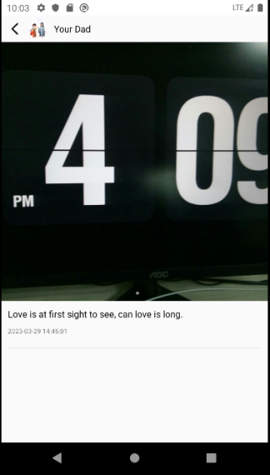

使用轮播图控件com.youth.banner控件展示用户上传的图片数据，并可左右滑动切换图片

public class PostDetailActivity extends BaseActivity {  
  
 @BindView(R.id.back_img)  
 ImageView backImg;  
 @BindView(R.id.user_img)  
 CircleImageView userImg;  
 @BindView(R.id.user_name)  
 TextView userName;  
 @BindView(R.id.banner)  
 Banner banner;  
 @BindView(R.id.content_tv)  
 TextView contentTv;  
 @BindView(R.id.time_tv)  
 TextView timeTv;  
  
 private String id;  
 private Post post;  
  
 @Override  
 protected void onCreate(Bundle savedInstanceState) {  
 super.onCreate(savedInstanceState);  
 //setContentView(R.layout.activity_post_detail);  
 }  
  
 @Override  
 protected void initView() {  
 if (isDark) {  
 ImmersionBar.with(mActivity).statusBarColor(R.color.white).statusBarDarkFont(false).init();  
 } else {  
 ImmersionBar.with(mActivity).statusBarColor(R.color.white).statusBarDarkFont(true).init();  
 }  
 id = getIntent().getStringExtra(Constants.ID);  
 if (!TextUtils.isEmpty(id)){  
 BmobQuery<Post> query = new BmobQuery<>();  
 query.include("author");  
 query.getObject(id, new QueryListener<Post>() {  
 @Override  
 public void done(Post object, BmobException e) {  
 if (e == null) {  
 post = object;  
 setData();  
 //Snackbar.make(mBtnEqual, "查询成功：" + object.size(), Snackbar.LENGTH_LONG).show();  
 } else {  
 Log.e("BMOB", e.toString());  
 //Snackbar.make(mBtnEqual, e.getMessage(), Snackbar.LENGTH_LONG).show();  
 }  
 }  
 });  
  
 }  
  
 }  
  
 private void setData() {  
 if (post != null){  
 User author = post.getAuthor();  
 if (author != null){  
 userName.setText(author.getNickName());  
 if (!TextUtils.isEmpty(author.getHeadPicture())){  
 Glide.with(mActivity).load(author.getHeadPicture()).into(userImg);  
 }  
 }  
 contentTv.setText(post.getContent());  
 timeTv.setText(post.getCreatedAt());  
  
 String str = post.getImage();  
 if (!TextUtils.isEmpty(str)){  
 String[] strArray = str.split(",");  
 List<String> imgList = new ArrayList<>(Arrays.asList(strArray));  
 banner.setImageLoader(new MyLoader());//加载图片 图片加载器  
 banner.setImages(imgList); //添加图片集合  
 banner.isAutoPlay(false); //是否自动轮播,true则为自动轮播，默认为true  
 banner.setDelayTime(24*60*60*1000); //设置每张图片显示的时间、单位秒  
 banner.setBannerStyle(BannerConfig.CIRCLE_INDICATOR);  
 banner.start();  
 /* //设置轮播图样式 共有6种 可以点进去更换查看不同样式  
 banner  
 //加载图片 图片加载器  
 .setImageLoader(new MyLoader())  
 //添加图片集合  
 .setImages(imgList)  
 //设置图片轮播的不同显示效果 可以点进去跟换样式  
 .setBannerAnimation(Transformer.Default)  
 //设置每张图片显示的时间  
 .setDelayTime(24*60*60*1000)  
 //是否自动轮播,true则为自动轮播，默认为true  
 .isAutoPlay(false)  
 //设置指示器的位置 左中右三种  
 .setIndicatorGravity(BannerConfig.CENTER)  
 //轮播图的监听  
 .setOnBannerListener(new OnBannerListener() {  
 @Override  
 public void OnBannerClick(int position) {  
  
 }  
 })  
 //启动轮播图 不要忘记  
 .start();*/  
  
 }  
  
 }  
 }  
  
 @Override  
 protected int setLayout() {  
 return R.layout.activity_post_detail;  
 }  
  
 @OnClick({R.id.back_img, R.id.user_img, R.id.user_name})  
 public void onViewClicked(View view) {  
 switch (view.getId()) {  
 case R.id.back_img:  
 finish();  
 break;  
 case R.id.user_img:  
 break;  
 case R.id.user_name:  
 break;  
 }  
 }  
  
 @Override  
 public void onBackPressed() {  
 super.onBackPressed();  
 finish();  
 }  
  
 //自定义的图片加载器  
 private class MyLoader extends ImageLoader {  
 @Override  
 public void displayImage(Context context, Object path, ImageView imageView) {  
 Glide.with(context).load((String) path).into(imageView);  
 }  
 }  
}

个人信息编辑页面：

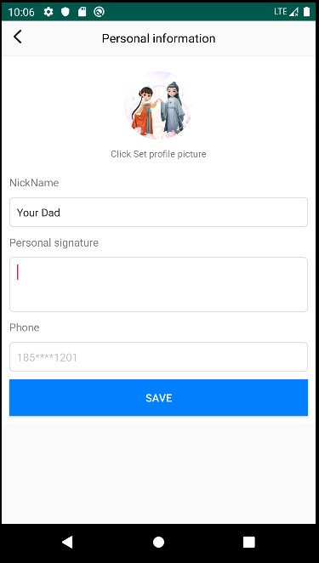

可修改昵称、头像、简介/个性签名等数据，并调用BMob提供的更新方法进行数据更新修改操作

public class EditInfoActivity extends BaseActivity {  
  
 @BindView(R.id.back_img)  
 ImageView backImg;  
 @BindView(R.id.back_layout)  
 LinearLayout backLayout;  
 @BindView(R.id.title_tv)  
 TextView titleTv;  
 @BindView(R.id.circle_img)  
 CircleImageView circleImg;  
 @BindView(R.id.name_edit)  
 EditText nameEdit;  
 @BindView(R.id.introduction_edit)  
 EditText introductionEdit;  
 @BindView(R.id.phone_edit)  
 EditText phoneEdit;  
 @BindView(R.id.login_btn)  
 Button loginBtn;  
  
 private User user;  
 private int requset_photo = 11;  
 private ProgressDialog progressDialog;  
 private StringBuilder img;  
  
 @Override  
 protected void onCreate(Bundle savedInstanceState) {  
 super.onCreate(savedInstanceState);  
 //setContentView(R.layout.activity_edit_info);  
 user = MyApplication.getInstance().getUser();  
 img = new StringBuilder();  
 if (user != null) {  
 //设置默认用户信息  
 if (!"No nickname".equals(user.getNickName()))  
 nameEdit.setText(user.getNickName());  
 introductionEdit.setText(user.getIntroduction());  
 if (!TextUtils.isEmpty(user.getPhone()))  
 phoneEdit.setText(user.getPhone().substring(0, 3) + "****" + user.getPhone().substring(7));  
 if (!TextUtils.isEmpty(user.getHeadPicture())){  
 Glide.with(mActivity).load(user.getHeadPicture()).into(circleImg);  
 }  
  
 }  
  
 }  
  
 @Override  
 protected void initView() {  
  
 }  
  
 @Override  
 protected int setLayout() {  
 return R.layout.activity_edit_info;  
 }  
  
 @OnClick({R.id.back_layout, R.id.circle_img, R.id.login_btn})  
 public void onViewClicked(View view) {  
 switch (view.getId()) {  
 case R.id.back_layout:  
 finish();  
 break;  
 case R.id.circle_img:  
 if (XXPermissions.isGranted(mContext, Manifest.permission.WRITE_EXTERNAL_STORAGE,  
 Manifest.permission.CAMERA,  
 Manifest.permission.READ_EXTERNAL_STORAGE)) {  
 Log.i(TAG, "hasPermission: ");  
 PictureSelector.create(this)  
 .openGallery(PictureMimeType.ofImage())  
 .maxSelectNum(1)  
 .isCamera(true)  
 .enableCrop(false)  
 .withAspectRatio(1, 1)  
 .compress(true)  
 .cropCompressQuality(40)  
 .forResult(requset_photo);  
 } else {  
 XXPermissions.with(this)  
 .permission(Manifest.permission.WRITE_EXTERNAL_STORAGE,  
 Manifest.permission.CAMERA,  
 Manifest.permission.READ_EXTERNAL_STORAGE)  
 .request(new OnPermissionCallback() {  
 @Override  
 public void onGranted(List<String> permissions, boolean all) {  
 if (all) {  
  
 } else {  
  
 }  
 }  
  
 @Override  
 public void onDenied(List<String> permissions, boolean never) {  
 if (never) {  
 // 如果是被永久拒绝就跳转到应用权限系统设置页面  
 XXPermissions.startPermissionActivity(mContext, permissions);  
 }  
 showToast("Authorization failure");  
 }  
 });  
 }  
 break;  
 case R.id.login_btn:  
 String nickName = nameEdit.getText().toString();  
 String introduction = introductionEdit.getText().toString();  
  
 if (TextUtils.isEmpty(nickName)){  
 showToast("Please enter a nickname");  
 return;  
 }  
  
 if (user != null){  
 user.setNickName(nickName);  
 if (!TextUtils.isEmpty(introduction))  
 user.setIntroduction(introduction);  
 if (img.length() != 0){  
 user.setHeadPicture(img.toString());  
 }  
 //调用修改方法 并监听回调  
 user.update(new UpdateListener() {  
 @Override  
 public void done(BmobException e) {  
 if (e == null){  
 //成功则更新本地数据  
 MyApplication.getInstance().setLoginUser(user);  
 showToast("Save successfully");  
 setResult(RESULT_OK);  
 finish();  
 }else {  
 showToast("Save failure,Please try again!");  
 }  
 }  
 });  
 }  
  
  
 break;  
 }  
 }  
  
 @Override  
 public void onBackPressed() {  
 super.onBackPressed();  
 finish();  
 }  
  
  
 @Override  
 protected void onActivityResult(int requestCode, int resultCode, @Nullable Intent data) {  
 super.onActivityResult(requestCode, resultCode, data);  
 if (requestCode == XXPermissions.REQUEST_CODE) {  
 if (XXPermissions.isGranted(this, Manifest.permission.READ_EXTERNAL_STORAGE,  
 Manifest.permission.WRITE_EXTERNAL_STORAGE)) {  
 //toast("用户已经在权限设置页授予了录音和日历权限");  
 } else {  
 //toast("用户没有在权限设置页授予权限");  
 new AlertDialog.Builder(mContext)  
 .setTitle("Tips")  
 .setCancelable(false)  
 .setMessage("Authorization failure")  
 .setPositiveButton("i know",  
 (dialogInterface, i) -> {  
 // 如果是被永久拒绝就跳转到应用权限系统设置页面  
 //System.exit(0);//正常退出  
 })  
 .show();  
 }  
 }  
 if (requestCode == requset_photo) {  
 if (data != null) {  
 List<LocalMedia> uris = PictureSelector.obtainMultipleResult(data);  
 List<File> files = new ArrayList<>();  
 List<String> pathList = new ArrayList<>();  
 if (uris.size() > 0) {  
 for (int i = 0; i < uris.size(); i++) {  
 if (uris.get(i).isCompressed()) {  
 pathList.add(uris.get(i).getCompressPath());  
 files.add(new File(uris.get(i).getCompressPath()));  
 } else {  
 files.add(new File(uris.get(i).getPath()));  
 pathList.add(uris.get(i).getPath());  
 }  
 }  
  
 Glide.with(mActivity).load(pathList.get(0)).into(circleImg);  
 if (files.size() > 0) {  
 progressDialog = ProgressDialog.show(this,"","In the picture uploaded");  
 progressDialog.show();  
 for (String str : pathList) {  
 BmobFile bmobFile = new BmobFile(new File(str));  
 bmobFile.uploadblock(new UploadFileListener() {  
  
 @Override  
 public void done(BmobException e) {  
 if (e == null) {  
 //bmobFile.getFileUrl()--返回的上传文件的完整地址  
 progressDialog.dismiss();  
 showToast("Upload successfully");  
 if (img.length() == 0)  
 img.append(bmobFile.getFileUrl());  
 else img.append(",").append(bmobFile.getFileUrl());  
 Log.e(TAG, "上传文件成功: " + img);  
 } else {  
 progressDialog.dismiss();  
 showToast("Upload failure");  
 Log.e(TAG, "上传文件失败: " + e.getMessage());  
 }  
 }  
  
 @Override  
 public void onProgress(Integer value) {  
 // 返回的上传进度（百分比）  
 }  
 });  
 }  
 }  
 }  
 }  
 }  
 }  
}

ChatFragment：（聊天室）

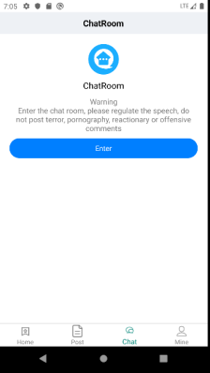

点击Enter键可以进入聊天室

public class ChatFragment extends BaseFragment {  
 @BindView(R.id.recycler_view)  
 RecyclerView recyclerView;  
 @BindView(R.id.create_btn)  
 Button createBtn;  
 @BindView(R.id.no_data_layout)  
 LinearLayout noDataLayout;  
 @BindView(R.id.create_tv)  
 TextView createTv;  
 private ChatRoomAdapter chatRoomAdapter;  
 private User loginUser;  
  
  
 /* @Override  
 public View onCreateView(LayoutInflater inflater, ViewGroup container,  
 Bundle savedInstanceState) {  
 // Inflate the layout for this fragment  
 return inflater.inflate(R.layout.fragment_chat, container, false);  
 }*/  
  
 @Override  
 protected int getLayoutId() {  
 return R.layout.fragment_chat;  
 }  
  
 @Override  
 protected void initEventAndData() {  
 loginUser = MyApplication.getInstance().getUser();  
 recyclerView.setLayoutManager(new GridLayoutManager(mContext, 2));  
 chatRoomAdapter = new ChatRoomAdapter(loginUser);  
 chatRoomAdapter.bindToRecyclerView(recyclerView);  
  
 getData();  
  
 }  
  
 private void getData() {  
 BmobQuery<ChatRoom> query = new BmobQuery<>();  
 //查询所有聊天室，包括查询创建者的信息和 人数  
 query.include("createUser,users");  
 query.order("-createdAt")  
 .findObjects(new FindListener<ChatRoom>() {  
 @Override  
 public void done(List<ChatRoom> object, BmobException e) {  
 if (e == null) {  
 if (object != null) {  
 if (object.size() == 0){  
 noDataLayout.setVisibility(View.VISIBLE);  
 }else {  
 noDataLayout.setVisibility(View.GONE);  
 }  
 chatRoomAdapter.setNewData(object);  
 }  
 } else {  
 }  
 }  
 });  
 }  
  
  
 @OnClick({R.id.create_btn, R.id.no_data_layout, R.id.create_tv})  
 public void onViewClicked(View view) {  
 switch (view.getId()) {  
 case R.id.create_tv:  
 case R.id.create_btn:  
 startActivityForResult(new Intent(mContext, CreateChatRoomActivity.class), 1001);  
 break;  
 case R.id.no_data_layout:  
 break;  
 }  
 }  
  
 @Override  
 public void onActivityResult(int requestCode, int resultCode, @Nullable Intent data) {  
 super.onActivityResult(requestCode, resultCode, data);  
 //新建聊天室成功后返回 重新请求数据  
 if (requestCode == 1001 && resultCode == Activity.RESULT_OK) {  
 getData();  
 }  
 }  
}

public class ChatFragment extends BaseFragment {  
 @BindView(R.id.recycler_view)  
 RecyclerView recyclerView;  
 @BindView(R.id.create_btn)  
 Button createBtn;  
 @BindView(R.id.no_data_layout)  
 LinearLayout noDataLayout;  
 @BindView(R.id.create_tv)  
 TextView createTv;  
 @BindView(R.id.btn_tv)  
 TextView btnTv;  
 private ChatRoomAdapter chatRoomAdapter;  
 private User loginUser;  
  
  
 /* @Override  
 public View onCreateView(LayoutInflater inflater, ViewGroup container,  
 Bundle savedInstanceState) {  
 // Inflate the layout for this fragment  
 return inflater.inflate(R.layout.fragment_chat, container, false);  
 }*/  
  
 @Override  
 protected int getLayoutId() {  
 return R.layout.fragment_chat;  
 }  
  
 @Override  
 protected void initEventAndData() {  
 loginUser = MyApplication.getInstance().getUser();  
 recyclerView.setLayoutManager(new GridLayoutManager(mContext, 2));  
 chatRoomAdapter = new ChatRoomAdapter(loginUser);  
 chatRoomAdapter.bindToRecyclerView(recyclerView);  
  
   
 }  
  
   
  
 @OnClick({R.id.create_btn, R.id.no_data_layout, R.id.create_tv,R.id.btn_tv})  
 public void onViewClicked(View view) {  
 switch (view.getId()) {  
 case R.id.btn_tv:  
 startActivity(new Intent(mContext, ChatActivity.class));  
 break;  
 case R.id.create_tv:  
 case R.id.create_btn:  
 startActivityForResult(new Intent(mContext, CreateChatRoomActivity.class), 1001);  
 break;  
 case R.id.no_data_layout:  
 break;  
 }  
 }  
  
 }

CreateChatRoomActivity：

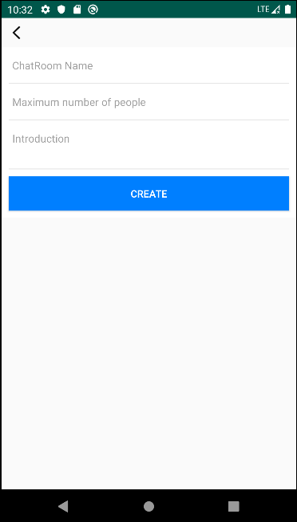

创建聊天室需填写聊天室名字，最大可加入的人数，以及聊天室的简介等。

创建成功后则返回至首页列表。

public class CreateChatRoomActivity extends BaseActivity {  
  
 @BindView(R.id.back_img)  
 ImageView backImg;  
 @BindView(R.id.name_edit)  
 EditText nameEdit;  
 @BindView(R.id.num_edit)  
 EditText numEdit;  
 @BindView(R.id.remake_edit)  
 EditText remakeEdit;  
 @BindView(R.id.login_btn)  
 Button loginBtn;  
 private User loginUser;  
 @Override  
 protected void onCreate(Bundle savedInstanceState) {  
 super.onCreate(savedInstanceState);  
 //setContentView(R.layout.activity_create_chat_room);  
 }  
  
 @Override  
 protected void initView() {  
 //获取当前登录人  
 loginUser = MyApplication.getInstance().getUser();  
  
 }  
  
 @Override  
 protected int setLayout() {  
 return R.layout.activity_create_chat_room;  
 }  
  
 @OnClick({R.id.back_img, R.id.login_btn})  
 public void onViewClicked(View view) {  
 switch (view.getId()) {  
 case R.id.back_img:  
 finish();  
 break;  
 case R.id.login_btn:  
 String name = nameEdit.getText().toString();  
 String remake = remakeEdit.getText().toString();  
 String num = numEdit.getText().toString();  
  
 if (TextUtils.isEmpty(name)){  
 showToast("Please enter ChatRoom name");  
 return;  
 }  
 if (TextUtils.isEmpty(num)){  
 showToast("Maximum number of people");  
 return;  
 }  
 if (TextUtils.isEmpty(remake)){  
 showToast("Please enter Introduction");  
 return;  
 }  
 //新建聊天室 并将填写的值赋给新建对象  
 ChatRoom chatRoom = new ChatRoom();  
 chatRoom.setCreateUser(loginUser);  
 chatRoom.setMaxNum(Integer.parseInt(num));  
 chatRoom.setName(name);  
 chatRoom.setRemake(remake);  
 chatRoom.save(new SaveListener<String>() {  
 @Override  
 public void done(String s, BmobException e) {  
 if (e == null){  
 showToast("Create successfully");  
 setResult(RESULT_OK);  
 finish();  
 }else {  
 showToast(e.getMessage());  
 }  
 }  
 });  
  
 break;  
 }  
 }  
  
 @Override  
 public boolean onKeyDown(int keyCode, KeyEvent event) {  
 if (keyCode == KeyEvent.KEYCODE_BACK) {  
 finish();  
 return false;  
 }  
 return super.onKeyDown(keyCode, event);  
 }  
}

MyPostActivity：我发布的帖子

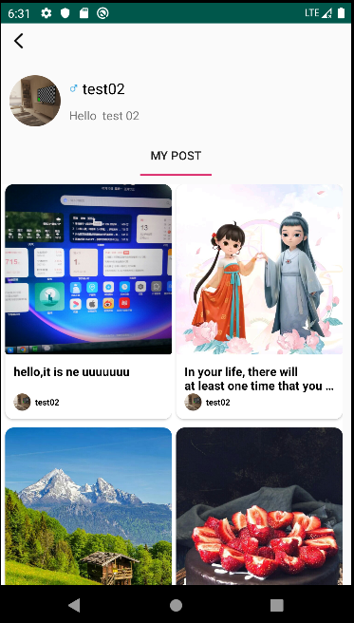

用于管理当前用户发布的所有帖子，可以进行修改、删除操作。

public class MyPostActivity extends BaseActivity {  
  
 @BindView(R.id.circle_img)  
 CircleImageView circleImg;  
 @BindView(R.id.name_tv)  
 TextView nameTv;  
 @BindView(R.id.introduction_tv)  
 TextView introductionTv;  
 @BindView(R.id.top_layout)  
 LinearLayout topLayout;  
 @BindView(R.id.tab_layout)  
 TabLayout tabLayout;  
 @BindView(R.id.view_pager)  
 ViewPagerForScrollView viewPager;  
 @BindView(R.id.back_img)  
 ImageView backImg;  
 @BindView(R.id.recycler_view)  
 RecyclerView recyclerView;  
 private User user;  
  
 private List<Fragment> mFragments;//fragment容器  
 private ArrayList<String> mTitle;//Tablayout标题容器  
 private MyPostFragment myPostFragment;  
  
 private GridLayoutManager layoutManager;  
 private PostAdapter postAdapter;  
  
 @Override  
 protected int setLayout() {  
 return R.layout.activity_my_post;  
 }  
  
 @Override  
 protected void onCreate(Bundle savedInstanceState) {  
 super.onCreate(savedInstanceState);  
 //setContentView(R.layout.activity_my_post);  
 }  
  
 @Override  
 protected void initView() {  
 user = MyApplication.getInstance().getUser();  
 if (user != null) {  
 MyApplication.getInstance().setLoginUser(user);  
 if (!TextUtils.isEmpty(user.getHeadPicture())) {  
 Glide.with(mActivity).load(user.getHeadPicture()).into(circleImg);  
 }  
 nameTv.setText(user.getNickName());  
 Drawable drawable;  
 if (user.getGender() == 0) {  
 drawable = mActivity.getResources().getDrawable(R.drawable.man);  
 } else {  
 drawable = mActivity.getResources().getDrawable(R.drawable.woman);  
 }  
 drawable.setBounds(0, 0, drawable.getIntrinsicWidth(), drawable.getIntrinsicHeight());  
 nameTv.setCompoundDrawables(drawable, null, null, null);  
 introductionTv.setText(user.getIntroduction());  
 }  
  
  
 mFragments = new ArrayList<>();//初始化fragment容器  
  
 myPostFragment = MyPostFragment.newInstance(user);  
  
  
 //将子fragment添加至容器  
 mFragments.add(myPostFragment);  
  
  
 mTitle = new ArrayList<>();  
 //将标题添加至容器  
 mTitle.add("My Post");  
  
  
 /**  
 * 预加载  
 */  
 //viewPager.setOffscreenPageLimit(mFragments.size());  
 /**  
 * 设置适配器  
 */  
 viewPager.setAdapter(new FragmentPagerAdapter(getSupportFragmentManager()) {  
 @Override  
 public Fragment getItem(int position) {  
 return mFragments.get(position);  
 }  
  
 @Override  
 public int getCount() {  
 return mFragments.size();  
 }  
  
 @Override  
 public CharSequence getPageTitle(int position) {  
 return mTitle.get(position);  
 }  
 });  
 tabLayout.setupWithViewPager(viewPager);//将Tablayout与viewpager进行关联  
 layoutManager = new GridLayoutManager(mActivity, 2);  
  
 recyclerView.setLayoutManager(layoutManager);  
 postAdapter = new PostAdapter(1);  
 postAdapter.bindToRecyclerView(recyclerView);  
 postAdapter.setOnItemClickListener((adapter, view, position) -> {  
 Post post = postAdapter.getItem(position);  
 if (post == null) return;  
 startActivity(new Intent(mContext, PostDetailActivity.class)  
 .putExtra(Constants.TYPE, 1)  
 .putExtra(Constants.ID, post.getObjectId()));  
 });  
 postAdapter.setOnItemLongClickListener(new BaseQuickAdapter.OnItemLongClickListener() {  
 @Override  
 public boolean onItemLongClick(BaseQuickAdapter adapter, View view, int position) {  
 Post post = postAdapter.getItem(position);  
 if (post != null) {  
 new AlertDialog.Builder(mContext)  
 .setTitle("Tip")  
 .setMessage("Are you sure you want to delete this?")  
 .setNeutralButton("sure", (dialog, which) -> {  
  
 post.delete(new UpdateListener() {  
 @Override  
 public void done(BmobException e) {  
 if (e == null) {  
 postAdapter.remove(position);//删除数据源,移除集合中当前下标的数据  
 postAdapter.notifyItemRemoved(position);//刷新被删除的地方  
 postAdapter.notifyItemRangeChanged(position, postAdapter.getItemCount()); //刷新被删除数据，以及其后面的数据  
 }  
 }  
 });  
  
 })  
 .setPositiveButton("cancel", new DialogInterface.OnClickListener() {  
 @Override  
 public void onClick(DialogInterface dialog, int which) {  
  
 }  
 })  
 .show();  
 }  
  
 return true;  
 }  
 });  
 getData();  
  
 }  
  
  
 private void getData() {  
 BmobQuery<Post> query = new BmobQuery<>();  
 //希望同时查询该评论的发布者的信息，以及该帖子的作者的信息，这里用到上面`include`的并列对象查询和内嵌对象的查询  
 query.addWhereEqualTo("author", user);  
 query.include("author");  
 query.order("-createdAt");  
 query.findObjects(new FindListener<Post>() {  
 @Override  
 public void done(List<Post> list, BmobException e) {  
 if (e == null) {  
 if (list != null) {  
 if (postAdapter != null)  
 postAdapter.setNewData(list);  
 }  
 }  
  
 }  
 });  
  
 }  
  
 @Override  
 protected void onResume() {  
 super.onResume();  
 getData();  
 }  
  
 @Override  
 public boolean onKeyDown(int keyCode, KeyEvent event) {  
 if (keyCode == KeyEvent.KEYCODE_BACK) {  
 finish();  
 return false;  
 }  
 return super.onKeyDown(keyCode, event);  
  
 }  
  
 @OnClick(R.id.back_img)  
 public void onViewClicked() {  
 finish();  
 }  
}

ChatFragment：

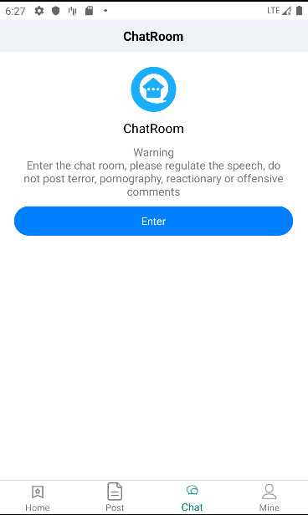

消息为群组消息，所有用户均可进入聊天室聊天。

ChatActivity：

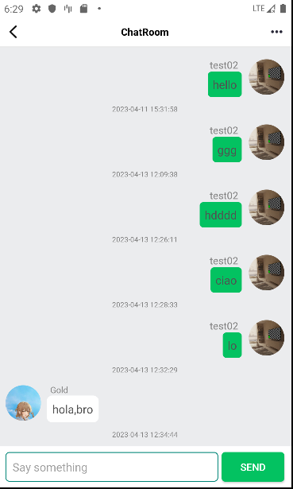

聊天界面：左侧为其他用户发送的消息，右侧为当前登录账号发送的消息

public class ChatActivity extends BaseActivity {  
 @BindView(R.id.back_img)  
 ImageView backImg;  
 @BindView(R.id.recycler_view)  
 RecyclerView recyclerView;  
 @BindView(R.id.refresh_layout)  
 SwipeRefreshLayout refreshLayout;  
 @BindView(R.id.content)  
 EditText content;  
 @BindView(R.id.fasong)  
 Button fasong;  
 @BindView(R.id.more_img)  
 ImageView moreImg;  
 private ChatAdapter chatAdapter;  
 private User loginUser;//当前登录人  
 private ChatBean lastChatBean;  
 private int page = 1;  
 private int isFirst = 0;  
 private MyTimeTask timeTask;  
  
 //间隔10s请求一次消息  
 private void startTask() {  
 timeTask = new MyTimeTask(new TimerTask() {  
 @Override  
 public void run() {  
 Log.e(TAG, "run: 请求消息");  
 getData();  
 }  
 });  
 timeTask.startTask(1000 * 10);  
  
 }  
  
 @Override  
 protected int setLayout() {  
 return R.layout.activity_chat;  
 }  
  
 @Override  
 protected void onCreate(Bundle savedInstanceState) {  
 super.onCreate(savedInstanceState);  
 //setContentView(R.layout.activity_chat);  
 }  
  
 @Override  
 protected void initView() {  
 if (isDark) {  
 ImmersionBar.with(mActivity).statusBarColor(R.color.white).statusBarDarkFont(false).init();  
 } else {  
 ImmersionBar.with(mActivity).statusBarColor(R.color.white).statusBarDarkFont(true).init();  
 }  
  
 recyclerView.setLayoutManager(new LinearLayoutManager(mContext));  
 loginUser = MyApplication.getInstance().getUser();  
 chatAdapter = new ChatAdapter(loginUser);  
 chatAdapter.bindToRecyclerView(recyclerView);  
  
 //开启定时任务  
 startTask();  
 }  
  
 private void getData() {  
 BmobQuery<ChatBean> query = new BmobQuery<>();  
 query.include("user");  
 query.findObjects(new FindListener<ChatBean>() {  
 @Override  
 public void done(List<ChatBean> object, BmobException e) {  
 if (e == null) {  
 if (object != null) {  
 Log.e(TAG, "done: " + object.size());  
 if (object.size() > 0) {  
 if (lastChatBean != null) {  
 ChatBean c = object.get(object.size() - 1);  
 if (lastChatBean.getObjectId().equals(c.getObjectId())) {  
  
 } else {  
 //如果有新消息，则直接加入消息列表  
 try {  
 for (int i = 0; i < object.size(); i++) {  
 for (int j = 0; j < chatAdapter.getData().size(); j++) {  
 if (object.get(i).getObjectId().equals(chatAdapter.getData().get(j).getObjectId())) {  
 object.remove(i);  
 i--;  
 }  
 }  
 }  
 } catch (ArrayIndexOutOfBoundsException ee) {  
 ee.printStackTrace();  
 }  
 chatAdapter.setNewData(object);  
 //列表滑动到最后一条消息处  
 recyclerView.smoothScrollToPosition(chatAdapter.getData().size());  
 }  
 } else {  
 chatAdapter.setNewData(object);  
 recyclerView.smoothScrollToPosition(chatAdapter.getData().size());  
 }  
 //记录最后一条消息  
 lastChatBean = object.get(object.size() - 1);  
 }  
 }  
 }  
 refreshLayout.setRefreshing(false);  
 }  
 });  
 }  
  
  
 @OnClick({R.id.back_img, R.id.fasong,R.id.more_img})  
 public void onViewClicked(View view) {  
 switch (view.getId()) {  
 case R.id.more_img:  
 startActivity(new Intent(mContext,UserListActivity.class));  
 break;  
 case R.id.back_img:  
 finish();  
 break;  
 case R.id.fasong:  
 //发送新消息  
 String name = content.getText().toString();  
 if (!TextUtils.isEmpty(name)) {  
 ChatBean chatBean = new ChatBean();  
 chatBean.setContent(name);  
 chatBean.setUser(loginUser);  
 chatBean.save(new SaveListener<String>() {  
 @Override  
 public void done(String s, BmobException e) {  
 if (e == null) {  
 //toast("添加数据成功，返回objectId为：" + objectId);  
 content.setText("");  
 chatAdapter.addData(chatBean);  
 lastChatBean = chatBean;  
 recyclerView.smoothScrollToPosition(chatAdapter.getData().size());  
 } else {  
 Log.e(TAG, "done: " + e.toString());  
 //toast("创建数据失败：" + e.getMessage());  
 showToast("Send failure," + e.getMessage() + " " + e.getErrorCode());  
 }  
 content.setText("");  
 content.clearFocus();  
 }  
 });  
 }  
 break;  
 }  
 }  
  
  
 @Override  
 public boolean onKeyDown(int keyCode, KeyEvent event) {  
 if (keyCode == KeyEvent.KEYCODE_BACK) {  
 finish();  
 return false;  
 }  
 return super.onKeyDown(keyCode, event);  
  
 }  
  
 @Override  
 protected void onDestroy() {  
 super.onDestroy();  
 if (timeTask != null) {  
 timeTask.stopTask();  
 }  
 }  
}

UserListActivity：

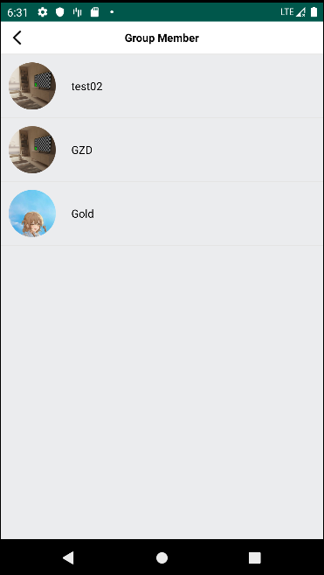

此界面为查看群组人员列表界面

public class UserListActivity extends BaseActivity {  
  
 @BindView(R.id.back_img)  
 ImageView backImg;  
 @BindView(R.id.recycler_view)  
 RecyclerView recyclerView;  
 @BindView(R.id.refresh_layout)  
 SwipeRefreshLayout refreshLayout;  
  
 private UserListAdapter userListAdapter;  
  
 @Override  
 protected void onCreate(Bundle savedInstanceState) {  
 super.onCreate(savedInstanceState);  
 //setContentView(R.layout.activity_user_list);  
 }  
  
 @Override  
 protected void initView() {  
  
  
 refreshLayout.setOnRefreshListener(new SwipeRefreshLayout.OnRefreshListener() {  
 @Override  
 public void onRefresh() {  
 getData();  
 }  
 });  
  
 recyclerView.setLayoutManager(new LinearLayoutManager(mContext));  
 userListAdapter = new UserListAdapter();  
 userListAdapter.bindToRecyclerView(recyclerView);  
 getData();  
 }  
  
 private void getData() {  
 //获取全部人员数据  
 BmobQuery<User> query = new BmobQuery<>();  
 query.findObjects(new FindListener<User>() {  
 @Override  
 public void done(List<User> object, BmobException e) {  
 if (e == null) {  
 if (object != null) {  
 userListAdapter.setNewData(object);  
 }  
 }  
 refreshLayout.setRefreshing(false);  
 }  
 });  
  
  
 }  
  
 @Override  
 protected int setLayout() {  
 return R.layout.activity_user_list;  
 }  
  
 @OnClick({R.id.back_img})  
 public void onViewClicked(View view) {  
 switch (view.getId()) {  
 case R.id.back_img:  
 onKeyDown(KeyEvent.KEYCODE_BACK,null);  
 break;  
  
 }  
 }  
  
  
 @Override  
 public boolean onKeyDown(int keyCode, KeyEvent event) {  
 if (keyCode == KeyEvent.KEYCODE_BACK){  
 finish();  
 return false;  
 }  
 return super.onKeyDown(keyCode, event);  
 }  
}

AboutActivity：

关于页面

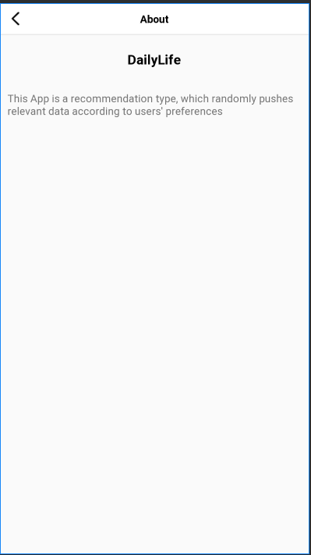

用于介绍此款app的类型、功能已经使用等 相关信息